Phillip Efthimion

Week 6 – Homework

#**************************

Please see the attached word document for the Homework.

#**************************

Please note all homework is due submitted on-line by 1PM CST (Dallas) on Saturday March 3rd.

Please submit an email to [cmaybin@smu.edu](mailto:cmaybin@smu.edu) titled MSDS_8390 - [Last Name] - Week 6 Homework. For example, my submission would be titled MSDS_8390 - Maybin - Week 6 Homework. In the email should be the following attachments containing the answers to the questions below:

* 1 word document with screenshots and code: Assignments 1 & 2.

Note: Files used during class have been loaded onto 2DS.

Regards,

Chad

#************************

Homework Section

#************************

For the following assignments, import the full data set (combining in R) and show your code at the end of this homework…

Assignment 1: Practical Learning - Tableau:

* **Create the following from your Tableau using the airline dataset and paste screenshot/output below:**

NOTE: Make sure and put your name and time stamp in the title…

Note2: Your total number of rows may/will be different depending on your machine RAM/methodology used to import data set…

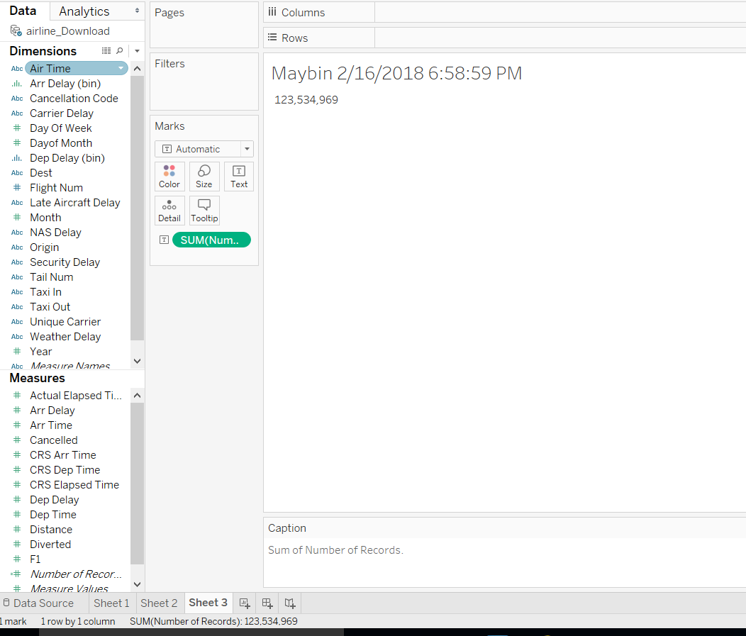



Assignment 2: Practical Learning - Tableau:

* **Create the following from your Tableau using the airline dataset and paste screenshot/output below:**

NOTE: Make sure and put your name and time stamp in the title…

Note2: Your total number of rows may/will be different depending on your machine RAM/methodology used to import data set…

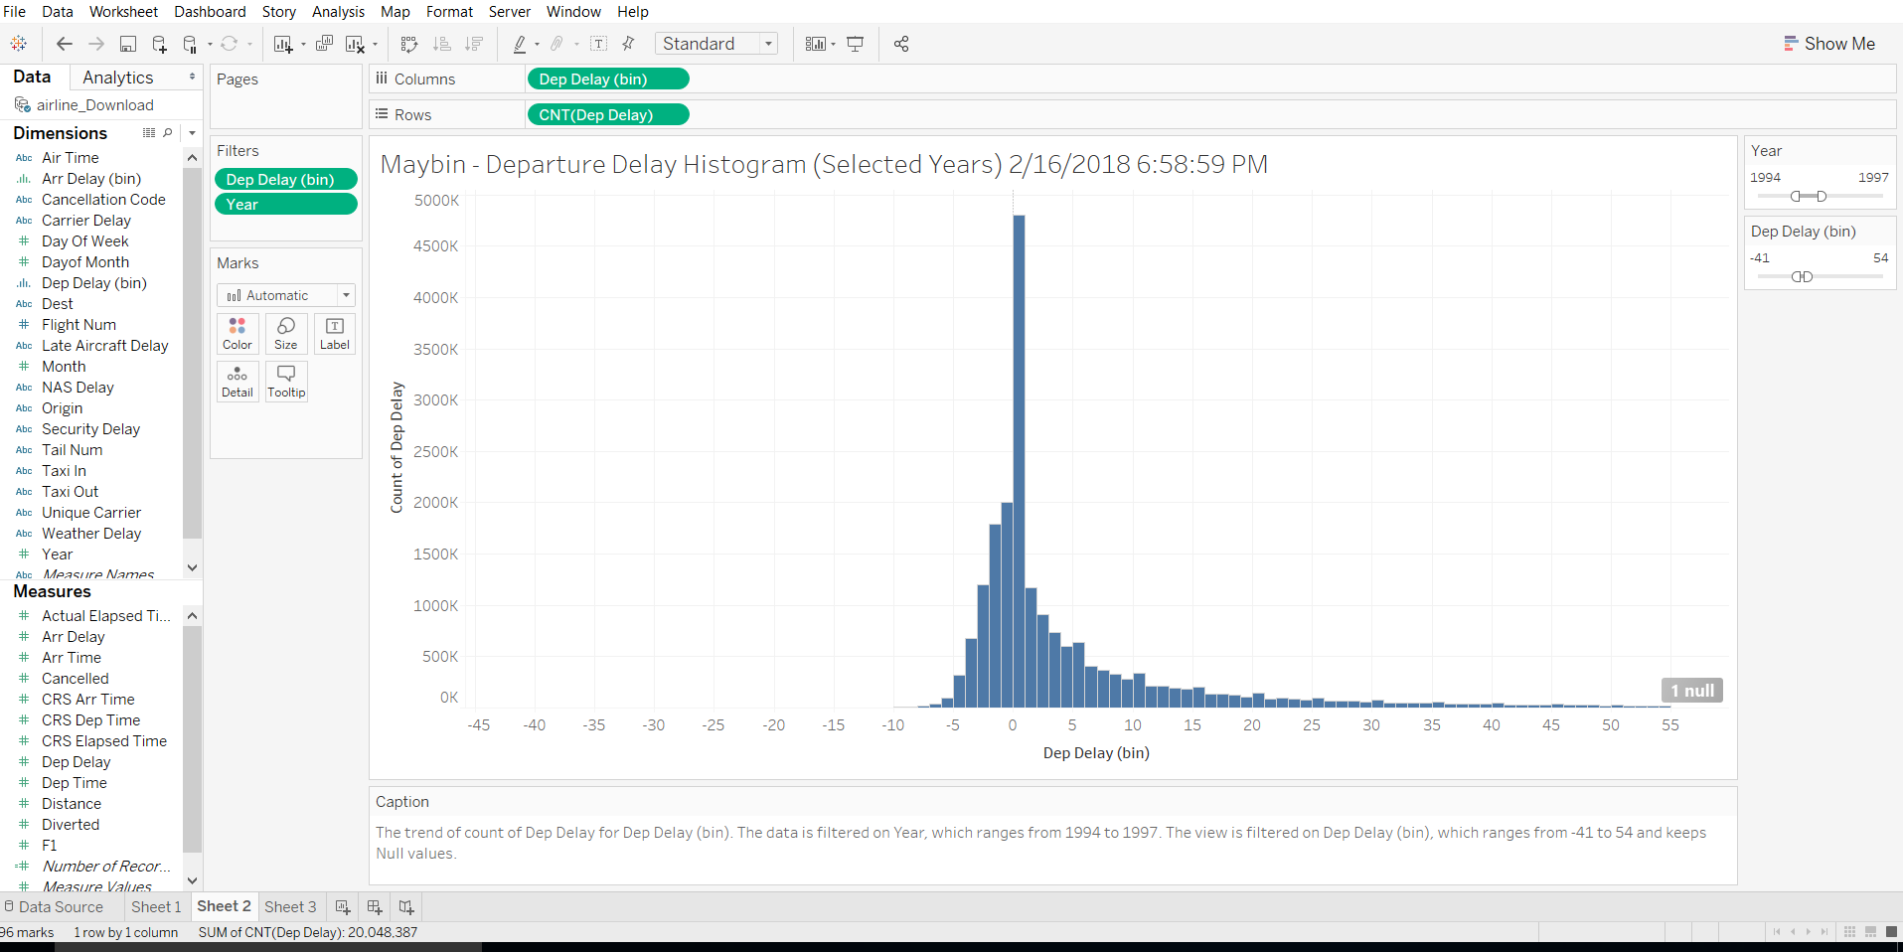



Sample export code titled “WK 5 - Airline Data” has been loaded onto 2DS. Make sure you put your name in the title…

Assignment 3: Put the R code you used to combine the airline dataset used in your tableau below:

# Phillip Efthimion

# R code for combining airline data taken from class example.

# Code slighlty changed to exclude years 87-90

#*****************

# Big Data - Airline Data Set Example

#*****************

#Make sure you do the below - you will need the memory when you load the full dataset...

rm(list = ls())

gc()

par(mfrow=c(1,1))

#Set the working directory...remeber to reset/change directory as needed...

setwd("/Users/Phillip/Documents/SMU/BusinessIntelligence/week6")

#read in the csv files...

# x_87 <- read.csv("1987.csv.zip")

# x_88 <- read.csv("1988.csv.bz2")

# x_89 <- read.csv("1989.csv.bz2")

# x_90 <- read.csv("1990.csv.bz2")

#Let's combine into one dataframe for simplicity...

# dfCombined <- rbind(x_87, x_88, x_89,x_90)

# nrow(dfCombined)

# rowCount <- nrow(x_87) + nrow(x_88) + nrow(x_89) + nrow(x_90) #to compare and make sure we have not dropped any rows...

# rm(x_87, x_88, x_89,x_90)

# identical(nrow(dfCombined), rowCount) #Are row counts same? True if yes...

# gc() #and clean up the memory...Note what it removes...

#OK, looks good so far...and for the next block.

x_91 <- read.csv("1991.csv")

x_92 <- read.csv("1992.csv")

x_93 <- read.csv("1993.csv")

x_94 <- read.csv("1994.csv")

#Let's combine into one dataframe for simplicity...

dfCombined <- rbind(x_91, x_92, x_93,x_94)

nrow(dfCombined)

rowCount <- nrow(x_91) + nrow(x_92) + nrow(x_93) + nrow(x_94) #to compare and make sure we have not dropped any rows...

rm(x_91, x_92, x_93,x_94)

identical(nrow(dfCombined), rowCount) #Are row counts same? True if yes...

gc()

#OK, looks good so far...and for the next block.

x_95 <- read.csv("1995.csv")

x_96 <- read.csv("1996.csv")

x_97 <- read.csv("1997.csv")

x_98 <- read.csv("1998.csv")

#Let's combine into one dataframe for simplicity...

dfCombined <- rbind(dfCombined,x_95, x_96, x_97,x_98)

nrow(dfCombined)

rowCount <- rowCount + nrow(x_95) + nrow(x_96) + nrow(x_97) + nrow(x_98) #to compare and make sure we have not dropped any rows...

rm(x_95, x_96, x_97,x_98)

identical(nrow(dfCombined), rowCount) #Are row counts same? True if yes...

gc()

#OK, looks good so far...and for the next block.

x_99 <- read.csv("1999.csv")

x_00 <- read.csv("2000.csv")

x_01 <- read.csv("2001.csv")

x_02 <- read.csv("2002.csv")

#Let's combine into one dataframe for simplicity...

dfCombined <- rbind(dfCombined,x_99, x_00, x_01,x_02)

nrow(dfCombined)

rowCount <- rowCount + nrow(x_99) + nrow(x_00) + nrow(x_01) + nrow(x_02) #to compare and make sure we have not dropped any rows...

rm(x_99, x_00, x_01,x_02)

identical(nrow(dfCombined), rowCount) #Are row counts same? True if yes...

gc()

#OK, looks good so far...and for the next block.

x_03 <- read.csv("2003.csv")

x_04 <- read.csv("2004.csv")

x_05 <- read.csv("2005.csv")

x_06 <- read.csv("2006.csv")

x_07 <- read.csv("2007.csv")

x_08 <- read.csv("2008.csv")

#Let's combine into one dataframe for simplicity...

dfCombined <- rbind(dfCombined,x_03, x_04, x_05,x_06, x_07,x_08)

nrow(dfCombined)

rowCount <- rowCount + nrow(x_03) + nrow(x_04) + nrow(x_05) + nrow(x_06)+ nrow(x_07) + nrow(x_08) #to compare and make sure we have not dropped any rows...

rm(x_03, x_04, x_05,x_06, x_07,x_08)

identical(nrow(dfCombined), rowCount) #Are row counts same? True if yes...

#OK, looks like all the data was successfully loaded. Let's clean up the memory and prep the bigdata file...

warnings() #No warnings, good to go...

gc() #Have the garbage collector clean up and release the memory...

write.csv(dfCombined, "airline_Download.csv") #For fun and learning, let's dump to csv file...

gc()